**KHYBER PAKHTUNKHWA HUMAN CAPITAL INVESTMENT PROJECT (kphcip)**

**Monitoring Report of ALP Centers**

**District Peshawar**

**Visit Date:** 12 June 2023

**District:** Peshawar

**Visiting Team:**  Maria Rehman (M&E Officer) and Asia Jaan (Education Officer)

**Visit Objective:**  Monitoring Visit of Accelerated Learning Program (ALP) Centers

**Report Prepared By:** Maria Rehman (M&E Officer)

The Project Implementation Unit (PIU), Accelerated Learning Program (ALP) is tasked to establish 327 ALP centers in the four selected project districts under KP-HCIP education. These centers aim to provide quality accelerated education to out-of-school children through a purposefully designed curriculum to enable children to catch up on lost time. The ALP centers under the project were established in April 2023 at Peshawar (107), Nowshera (114), Haripur (34), and Swabi (72), with a focus on Afghan refugees children and the hosting communities. The centers operate in morning and evening shifts to facilitate the children.

The objective of the visit was to assess the establishment and operational status of these centers, and the availability of the supplies provided by the ALP-PIU under the project. Additionally, to take feedback from students, teachers, and community in general about the ALP centers.

**On 12 Jun 2023, three ALP centers in District Peshawar were visited following;**

|  |  |  |  |  |  |
| --- | --- | --- | --- | --- | --- |
| **Sr#** | **Center Name** | **Gender** | **Total Learners Enrolled** | **Local Learners** | **Afghan Refugees** |
| 1 | ALP Center Shaikh Abad | Female | 36 | 36 | 0 |
| 2 | ALP Center Shaikh Abad No. 03 | Female | 35 | 29 | 6 |
| 3 | Shaheen Muslim Town Gulbahar | Female | 31 | 25 | 6 |
| **Total** | | | **102** | **90** | **12** |

**Center wise details are as follows;**

**01. ALP Center Shaikh Abad (Female)**

|  |  |  |  |  |  |
| --- | --- | --- | --- | --- | --- |
| Total Learners Registered | Local Learners | Afghan Refugees | Withdrawal | Present at the time of visit | No. Of Facilitators |
| 36 | 36 | 00 | 02 | 22 | 02 |

**Key Findings:**

* The center is located in the facilitator house and has been operational since April 1st, 2023.
* During visit, it was observed that the center operated during the morning shift with timings from 07:30 am to 12:30 pm.
* 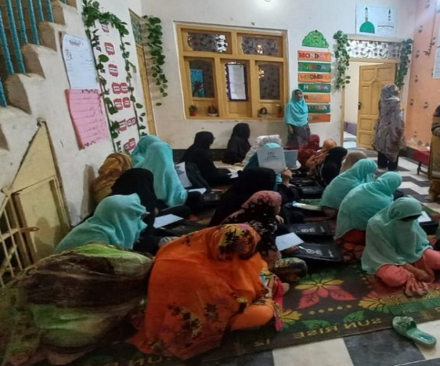Supplies including Sign Board, School Bags, Notebooks, White Board, Package-D, Dictionaries, Water Cooler, two steel Glasses and Charts were provided to this center by the ALP-PIU.

Figure ; View of ALP center

* According to the facilitators, PIU will pay them an amount of 1500 for electricity bill.
* The Learners were properly accommodated in the lobby area.
* The Light system was sufficient and met the requirements.
* Clean drinking water was readily available in this center.
* Washroom facility was available at the center and was functional.
* The age range of the learners in this center was between 12 and 18 years.
* Both facilitators (Ms. Sidra and Ms. Bibi Zainab) were local residents of the area and were present at the center.
* 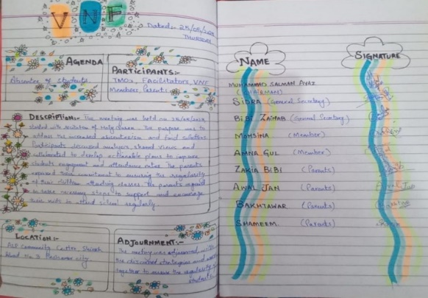Facilitators received a contractual agreement for a period of nine months, from April to December 2023 and they also received a stipend for the first two months (April-May 2023).
* In this center, a Volunteer Network Forum (VNF) was formed, comprising of 08 members, including 07 females and 01 male chairperson. A meeting of the VNF was held on May 25, 2023. The roles and responsibilities of the VNF were not displayed, although they were properly recorded and updated in the VNF registers, which also contained detailed information about the members.

Figure : VNF register updated

* Based on feedback from the learners, the center is conveniently located and they have no issue regarding the timings.

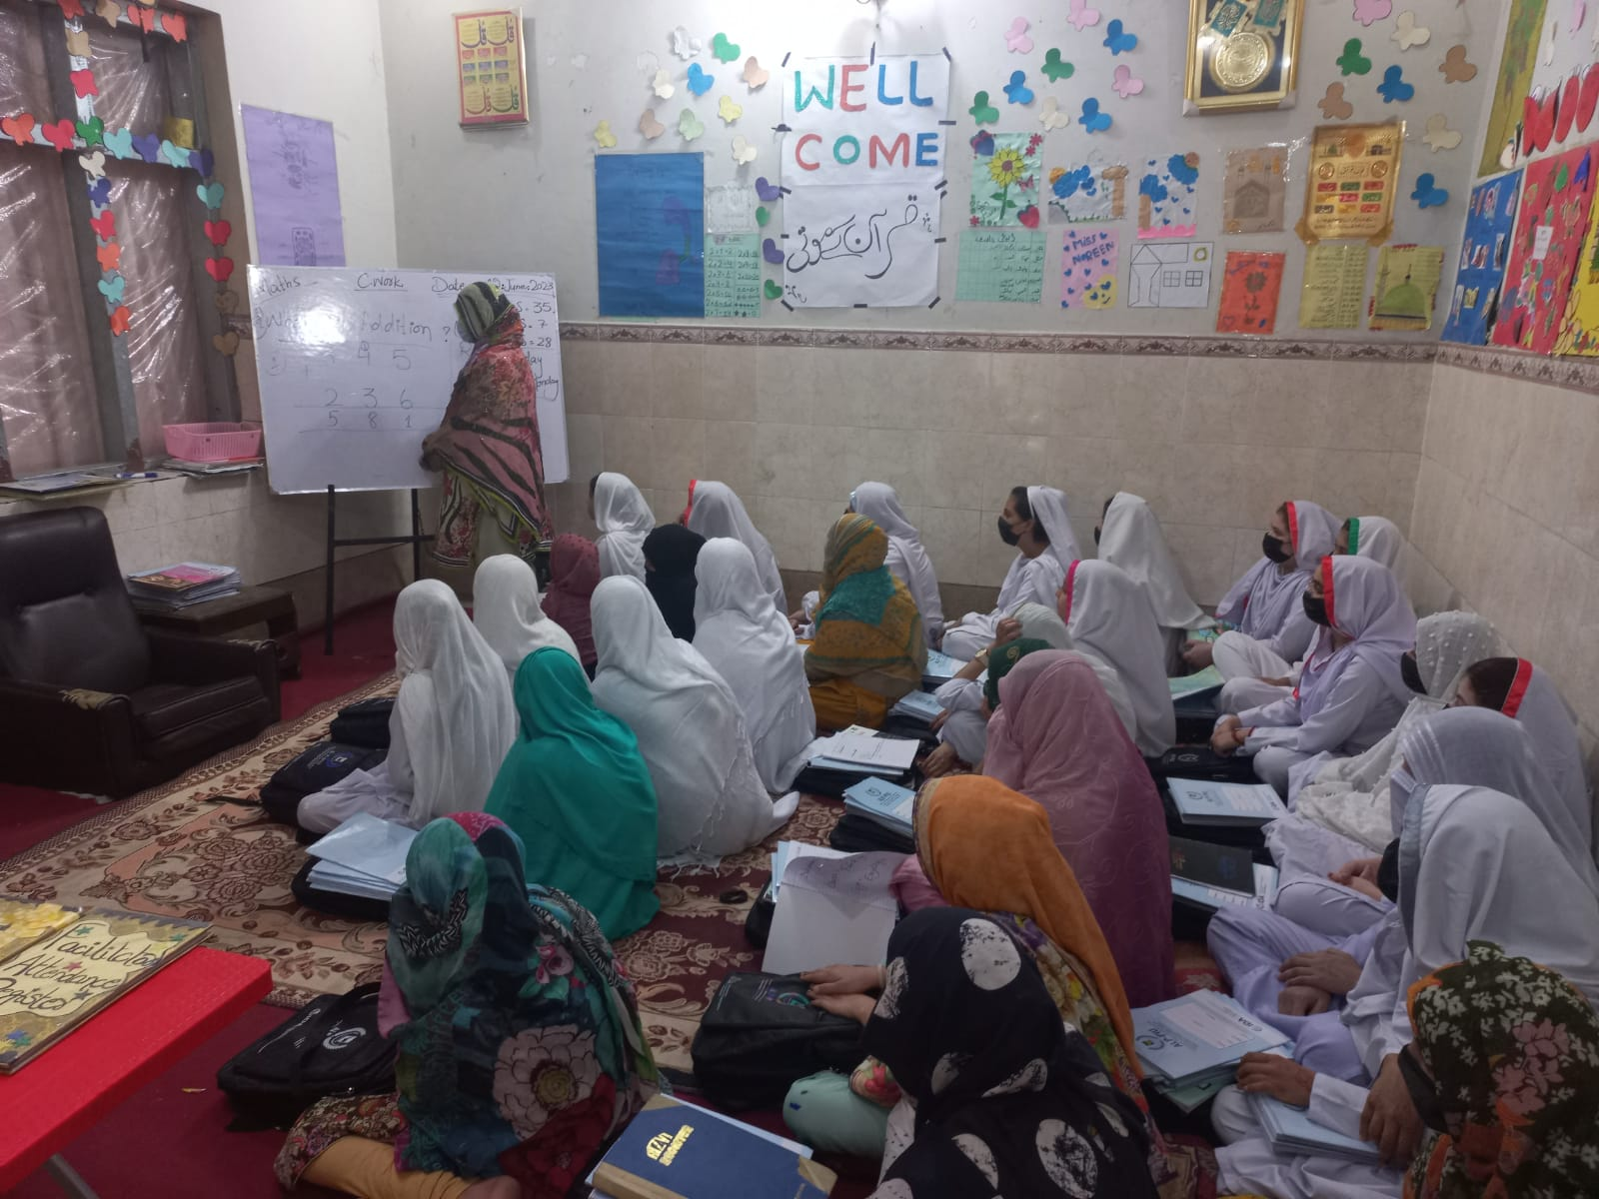**02. ALP Center Shaikh Abad No. 03 (Female)**

Figure : Inside view of ALP Center

|  |  |  |  |  |  |
| --- | --- | --- | --- | --- | --- |
| Total Learners Registered | Local Learners | Afghan Refugees | Withdrawal | Present at the time of visit | No. Of Facilitators |
| 35 | 29 | 06 | 00 | 28 | 02 |

**Key Findings:**

* The center has been operational since April 04, 2023 and was placed in the facilitator house.
* The center operated during the morning shift with timings from 07:30 am to 01:00 pm.
* Supplies including Sign Board, School Bags, Notebooks, White Board, Package-D, Dictionaries, Water Cooler, Two Steel Glasses and Charts were provided to this center by the ALP-PIU.
* 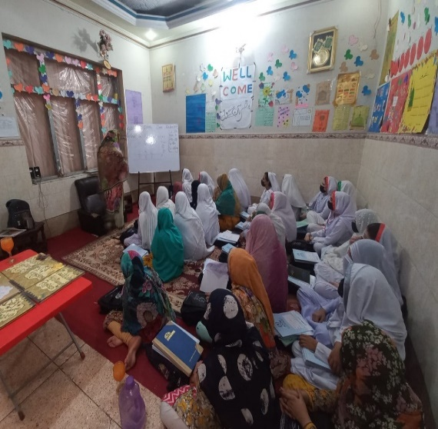During discussion with the facilitators, it was revealed that the PIU would reimburse them an electricity bill, amounting to 1500.

Figure : Facilitator taking Class

* The Learners were accommodated in the lobby area with sufficient lighting for their needs.
* The center had a proper washroom facility.
* Both facilitators (Ms. Maryam Hayat and Ms. Noreen Shoukat) were local of the area and were present at the center.
* A Volunteer Network Forum (VNF) was formed, comprising of 08 members, including 05 females and 03 male. A meeting of the VNF was held on May 30, 2023. Roles and responsibilities of the VNF were not displayed, though they were documented and updated in the VNF registers along with members details.

**03. ALP Center Shaheen Muslim Town Gulbahar (Female)**

|  |  |  |  |  |  |
| --- | --- | --- | --- | --- | --- |
| Total Learners Registered | Local Learners | Afghan Refugees | Withdrawal | Present at the time of visit | No. Of Facilitators |
| 31 | 25 | 06 | 04 | 20 | 02 |

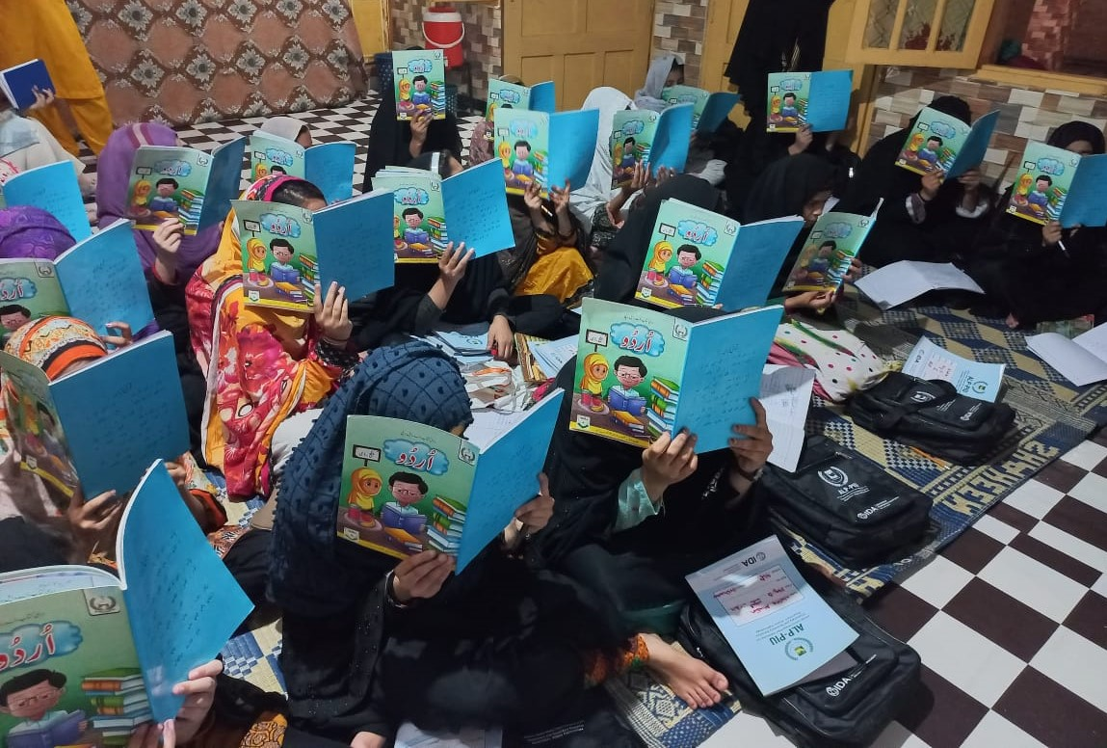

Figure : Learners engaged during Class

**Key Findings:**

* The center has been operational since April 1st, 2023 and was located in the rented room (10000/Month).
* 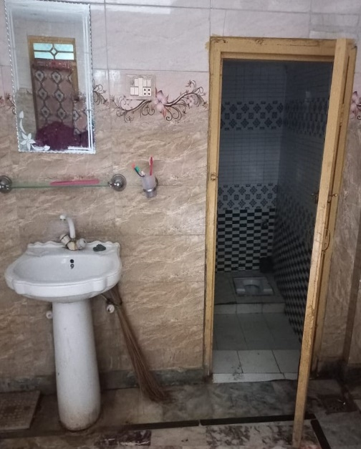The center had an evening shift with the timings from 12:00 pm to 05:00 pm.

Figure : Washroom facility for the learners

* Supplies including Sign Board, School Bags, Notebooks, White Board, Package-D, Dictionaries, Water Cooler and Charts were provided to this center by the ALP-PIU.
* The Learners were accommodated in a very congested room with insufficient lighting, resulting in inadequate space to properly accommodate them.
* Washroom was available for the learners and it was functional.
* Both facilitators (Ms. Touheed and Ms. Nafeesa) were residents of the area and were present at the center. They met the required qualification as per the agreed criteria.
* Upon asking about the utility bills, it was revealed that PIU would provide a reimbursement of 1500 for the electricity bill.
* 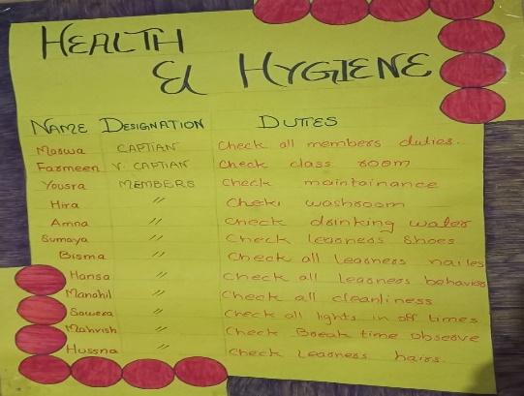A Volunteer Network Forum (VNF) was formed, comprising of 08 members, including 07 females and 01 male. A meeting of the VNF was held on May 29, 2023. The roles and responsibilities of the VNF were not displayed, although they were properly recorded and updated in the VNF registers, which also contained detailed information about the members.

Figure : Health & Hygiene activities plan displayed

* The center actively conducts regular health and hygiene activities.
* **According to the facilitator, there is an increasing number of learners seeking admission to this center. However, she mentioned that the ALP-PIU has set a policy limiting the enrollment of learners to a maximum of 35 per center. Hence, there is a need for more centers.**

**Major Findings;**

* All the centers were successfully established and operational.
* The centers were provided with necessary supplies including Sign boards, White Boards, School Bags, Notebooks, Package-D and Water Cooler and two glasses by the PIU.
* A set of six registers, including Learners Attendance, Staff Attendance, VNF, Stock, Learners Admission and Withdrawals and Visitors Register was provided to each center. These registers were thoroughly maintained and updated.
* The centers did not receive any payments for electricity bills, although facilitators shared that PIU would pay them an amount of 1500.
* During the visit, it was observed that each center had an enrollment range of 30 to 35 learners with two allocated facilitators present at each center.
* Village Network Forum (VNF) was found functional, including eight members each forum. Roles and responsibilities of the VNF, as well as meeting minutes were updated and recorded in the VNF registers.
* All the facilitators received a stipend of 50000 for the duration of two months.

**Recommendations/Suggestions:**

Based on the observations and findings mentioned above, the following suggestions and recommendations are proposed to enhance ALP centers;

1. Provide training and professional development opportunities for facilitators to enhance their skills in managing ALP centers effectively.
2. Establish a support system for facilitators to address their concerns, provide guidance, and promote their continuous professional growth.
3. Encourage active participation of community members and ensure their participation through organizing regular meetings, awareness campaigns and parent teachers interactions.
4. Ensure that the ALP centers have sufficient educational resources, including textbooks, **stationery**, and learning materials, to facilitate effective teaching and learning.